Sample Abstract for ICOSSAR2021 (16pt bold)
First E. Authorª and Second R. Author^{b} (12 pt)

ªInstitute of Extraterrestrics, University of Jupiter (9 pt), E-mail: abc@def.edu.
^{b}Software Development, Macrosoft Venus Inc., E-mail: abc1@def.edu.

Abstract (14 pt bold)
Please use the typeface Times New Roman throughout. General font size is 12 pt. Fonts for Title, Headings etc. are given in this document. The page size is A4, page margins are: top = 2.5 cm, bottom = 2.5 cm, left = 2.5 cm, right = 2.5 cm. Note that 2.5 cm equals 1 in. Please do not add any header/footer lines nor page numbers.
Equation numbers start at (1), Figures and pictures are labeled ”Figure” starting with Figure 1. Analogously for tables. Literature is referenced in square brackets [], e.g., the probability of failure can be computed as [1]

(1)

References should be listed in alphabetical order by last name of the first author.
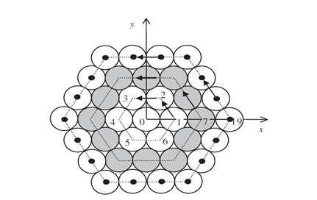
Figure 1. Numbering centers of tangent circles

Key words: abc; edf; ghi

Please note: The abstract is limited in ONE page and must be uploaded in WORD format.

References (14 pt bold)
- Der Kiureghian, A. and Dakessian, T., 1998 Multiple design points in first and second-order reliability. Structural Safety, 20(1): 37-49.
- Ditlevsen, O. and Madsen, H.O., 1996. Structural Reliability Methods. John Wiley & Sons, New York.
- Valdebenito, M.A., Jensen, H.A., Schuëller, G.I. and Labarca, A.A., 2012. Reliability analysis of linear dynamical systems with uncertain structural parameters subject to discrete white noise excitation. The 6th European Congress on Computational Methods in Applied Sciences and Engineering (ECCOMAS 2012), Vienna, Austria.
- Bucher, C., 2009. Computational analysis of randomness in structural mechanics. In D.M. Frangopol (Ed.), Structures and Infrastructures Book Series, Vol. 3, Taylor & Francis, London, pp. xxx-xxx.

